FRED will use an Arduino UNO Wifi

Currently testing on Arduino UNO R3

Images are of the wiring

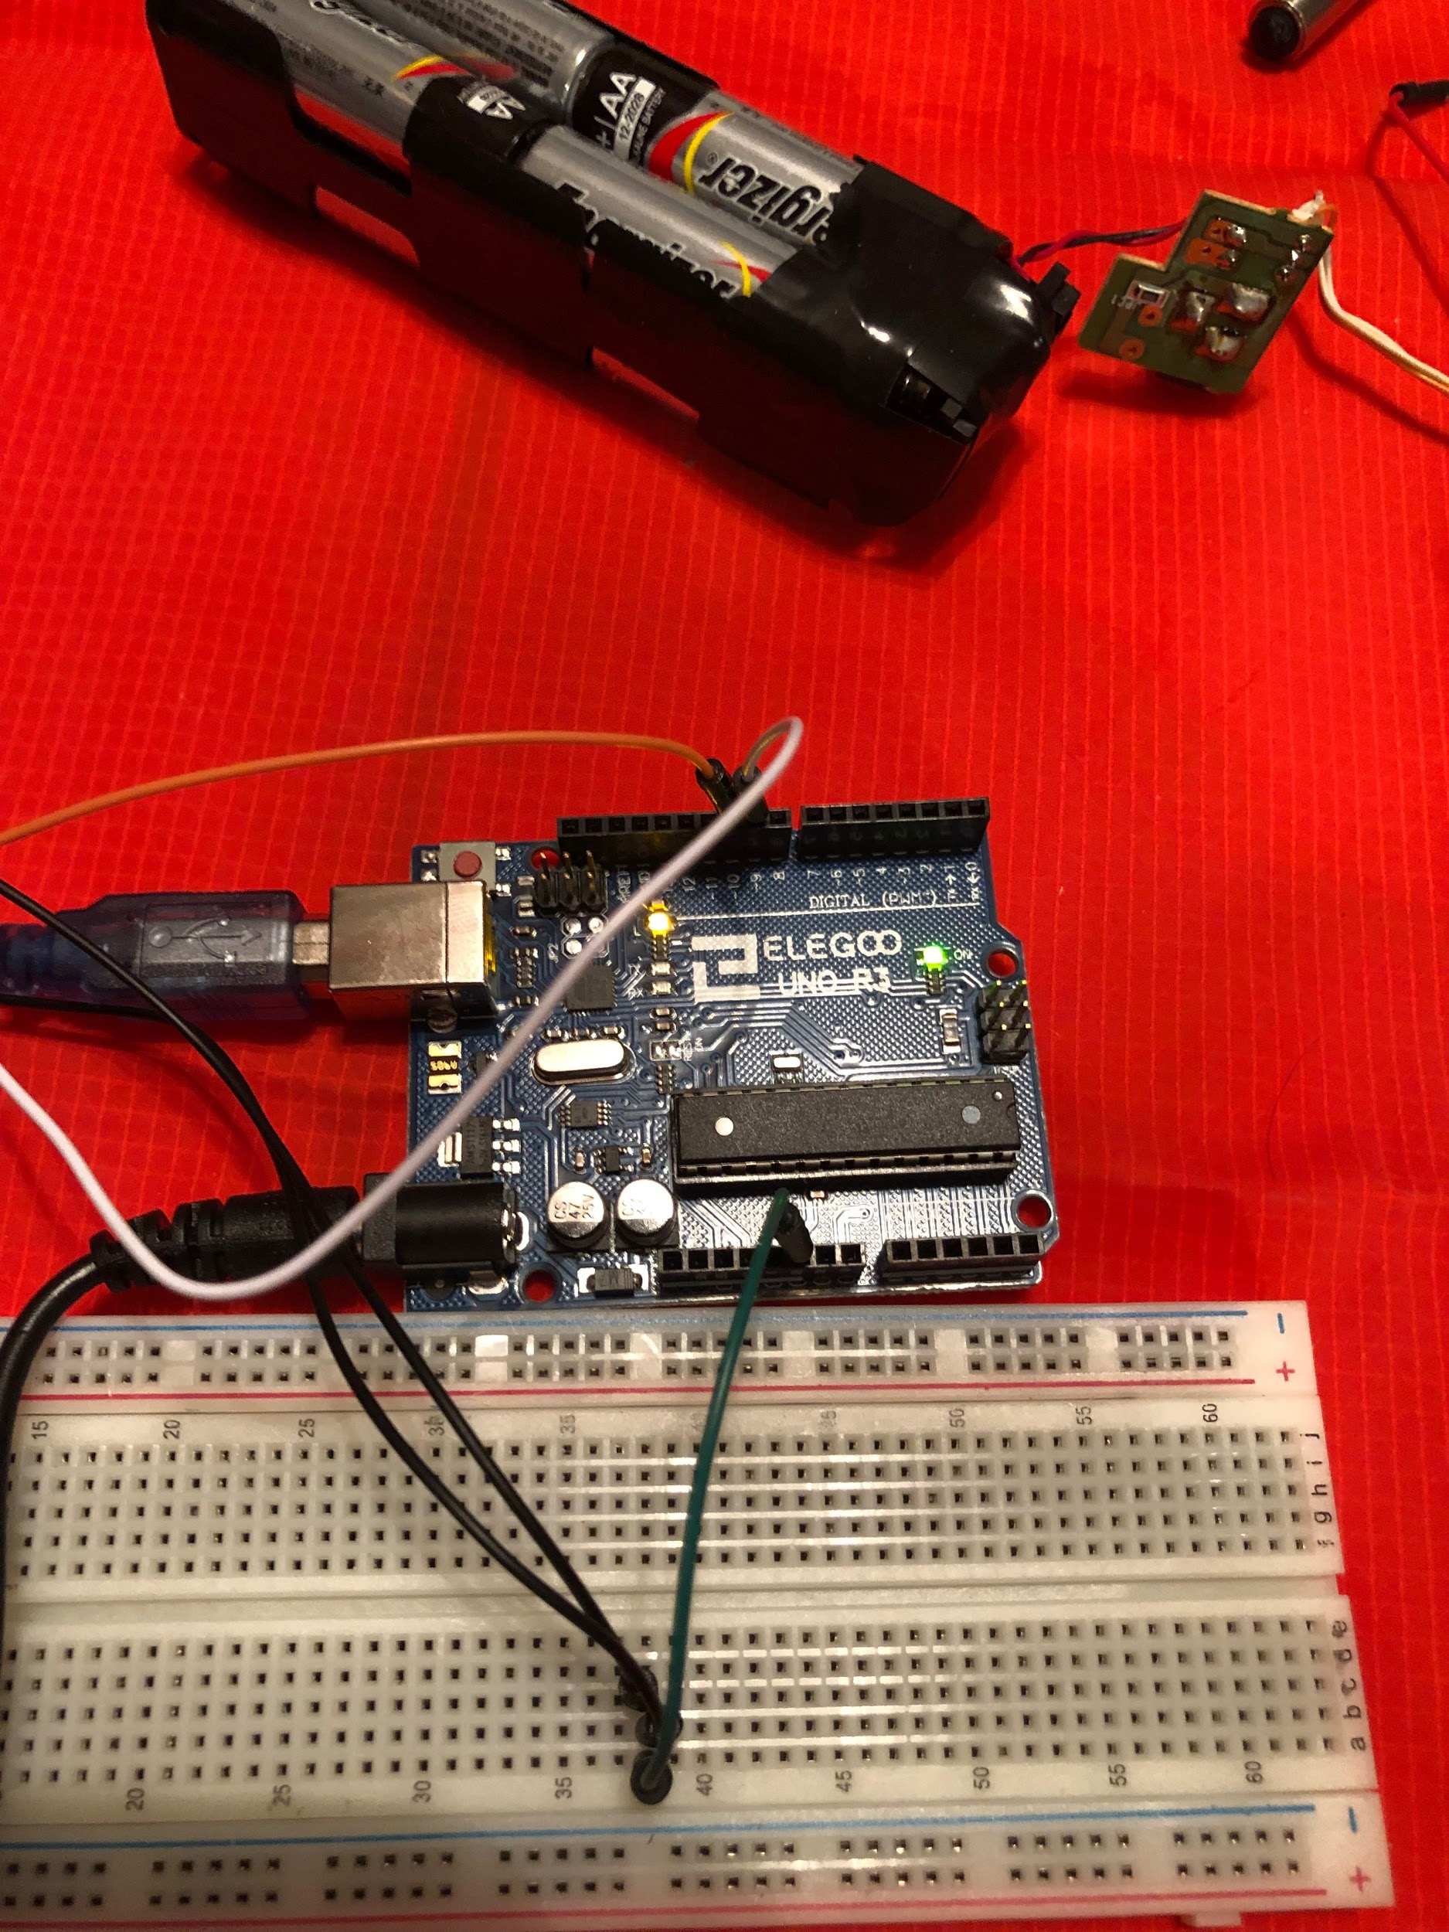

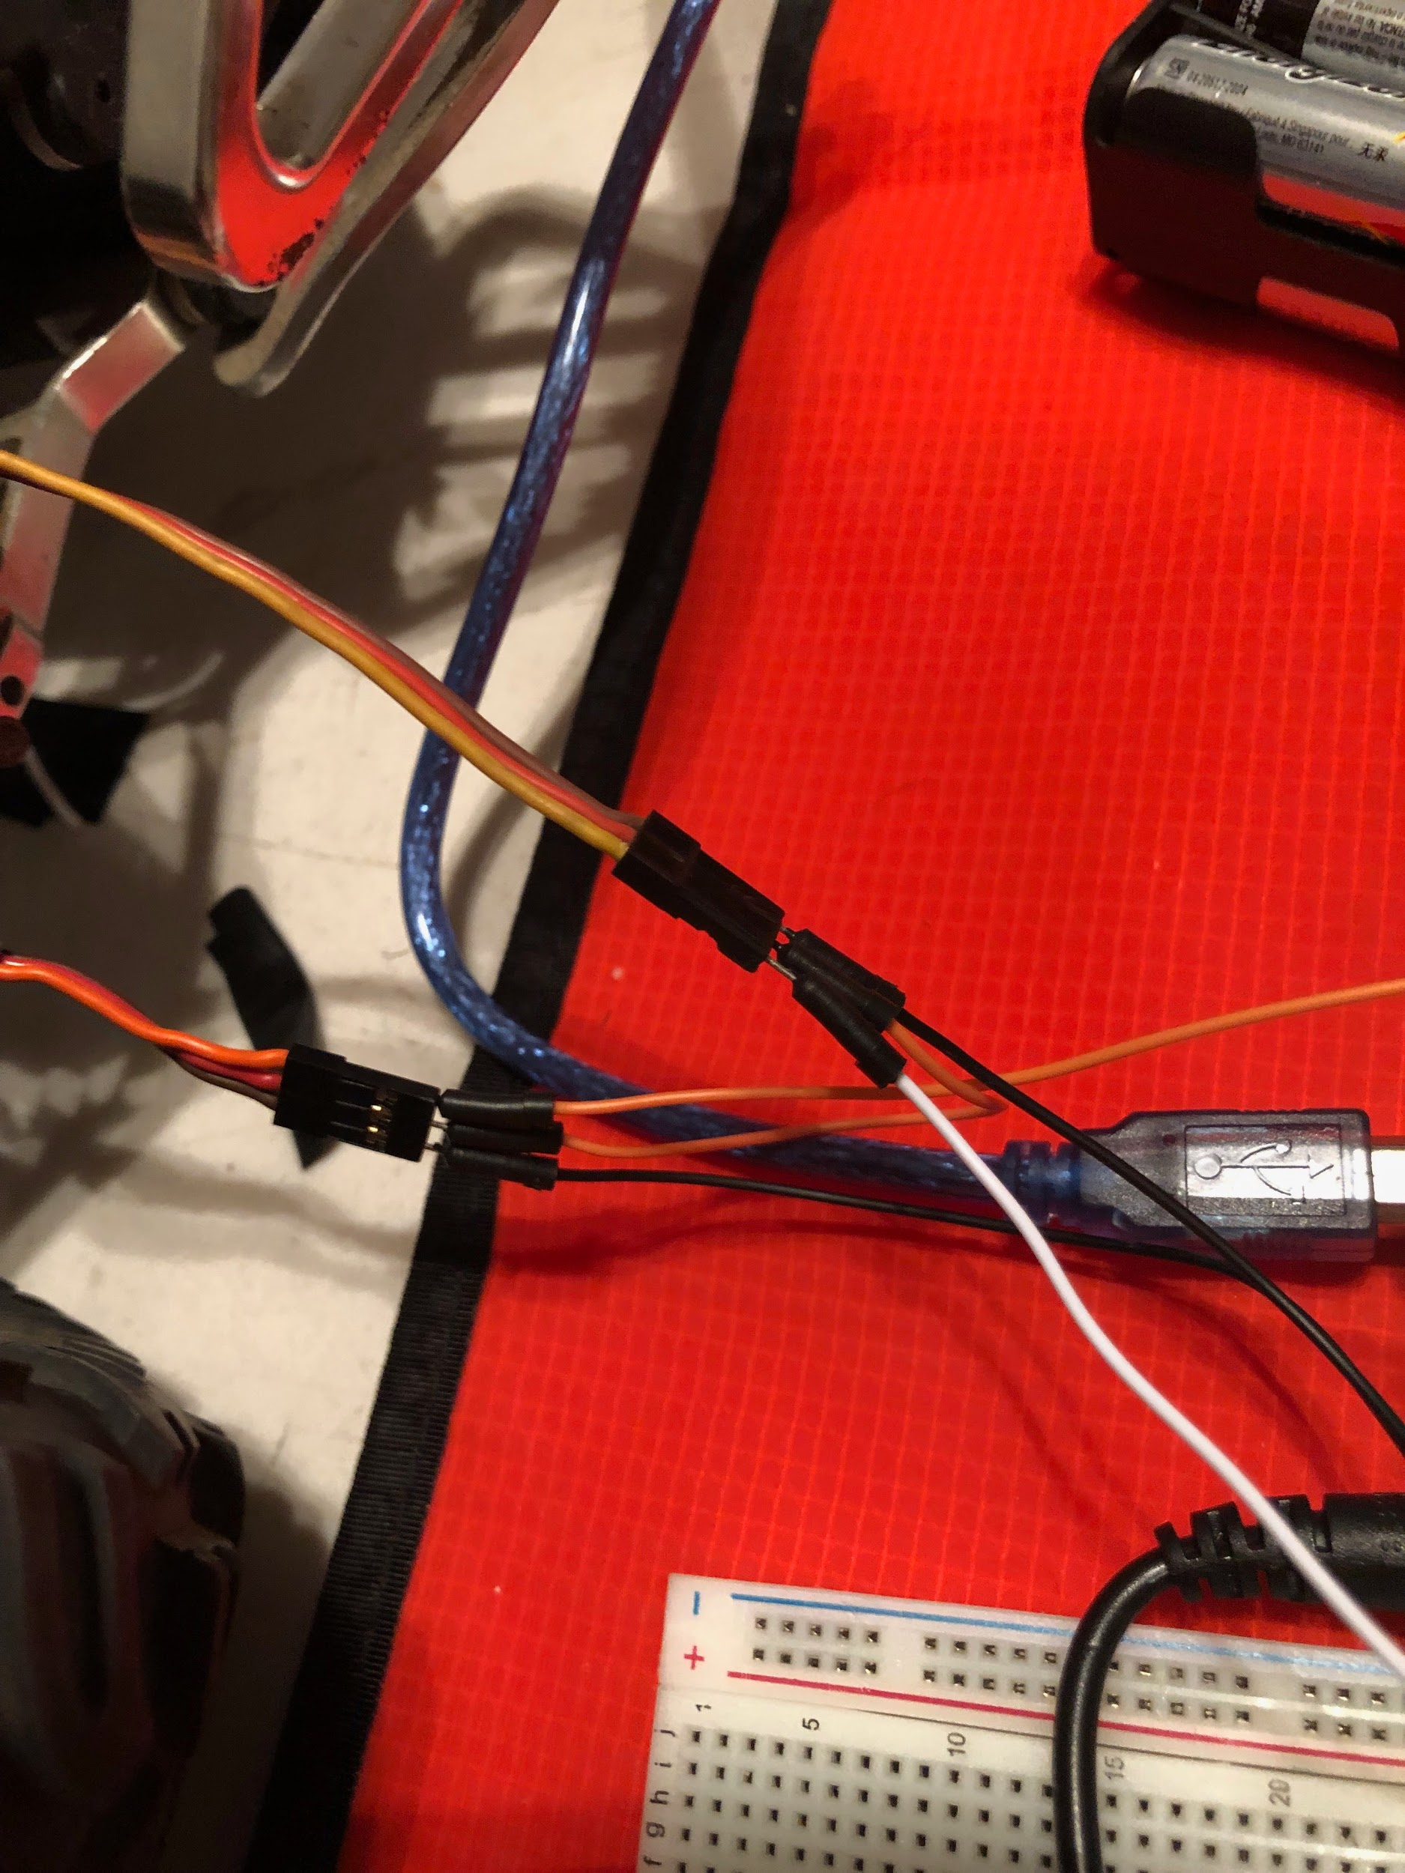

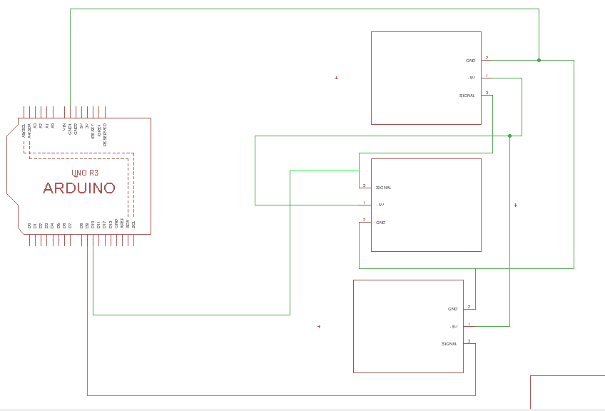

The Basics Of The Schematics